TASK-ON JENKINS-03
1. Create one Jenkins job using the below code and create three stages.
stage1: Git clone to download the source code.
stage2: Sonarqube Integration to check the quality of code.
stage3: Slack Integration to send the alerts to slack.
Source Code: https://github.com/betawins/VProfile-1.git

Install Required Tools
Jenkins installed (running on port 8080/8081)
Java installed
Git installed
2. Install Jenkins Plugins
Go to: Manage Jenkins → Plugins → Available Plugins
Install:
Git Plugin
Pipeline Plugin
SonarQube Scanner
SonarQube Plugin
Slack Notification Plugin

INSTALL SONARQUBE (WITH UI) – STEP BY STEP (LINUX / EC2)
🔹 Step 1: Install Java (Required)
sudo apt update
sudo apt install openjdk-17-jdk -y
Check:
java -version

🔹 Step 2: Download SonarQube
sudo useradd sonar
sudo passwd sonar
Sonar@123
cd /opt
sudo wget https://binaries.sonarsource.com/Distribution/sonarqube/sonarqube-9.9.3.79811.zip
sudo unzip sonarqube-9.9.3.79811.zip
sudo mv sonarqube-9.9.3.79811 sonarqube
sudo chown -R sonar:sonar /opt/sonarqube
su – sonar
cd /opt/sonarqube/bin/linux-x86-64
./sonar.sh start
./sonar.sh status
http://<your-ec2-ip>:9000
IMPORTANT (EC2 USERS )
Go to AWS Security Group:
Add rule:
Port: 9000
Source: 0.0.0.0/0
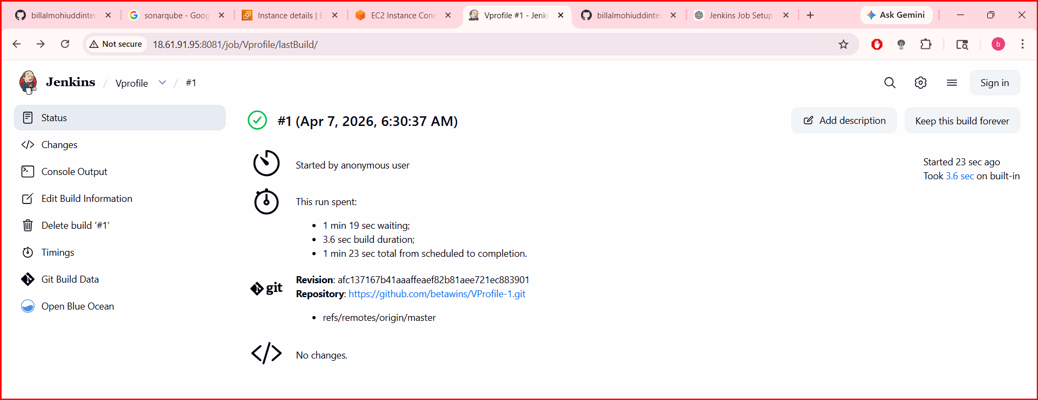
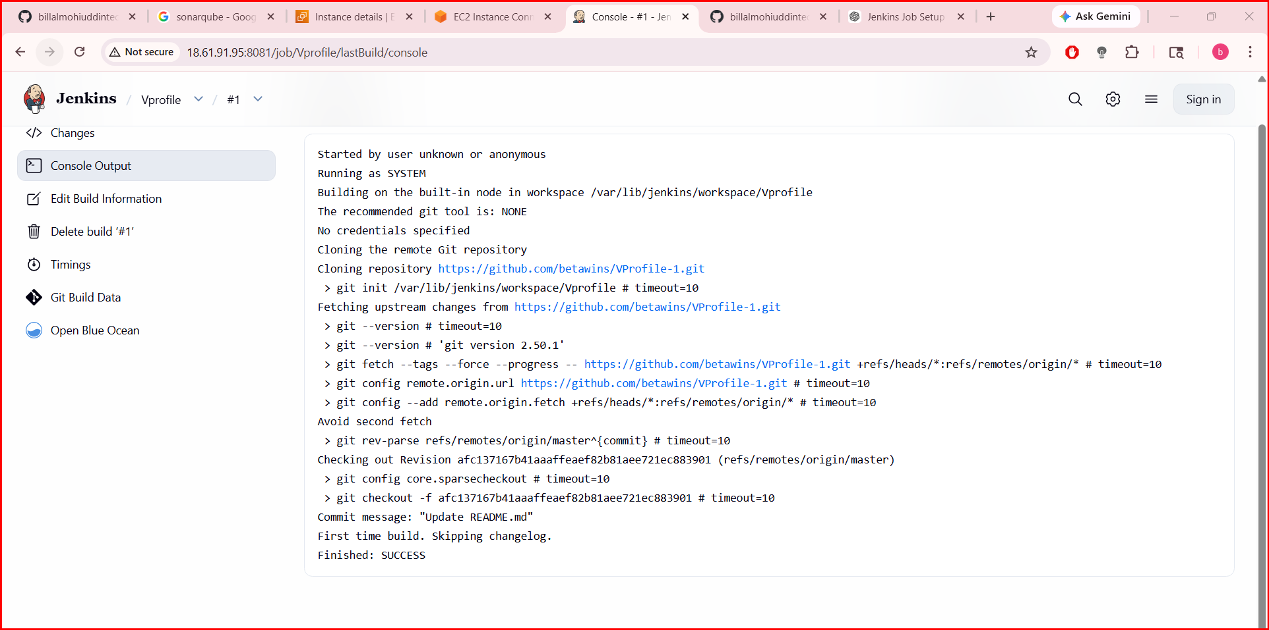
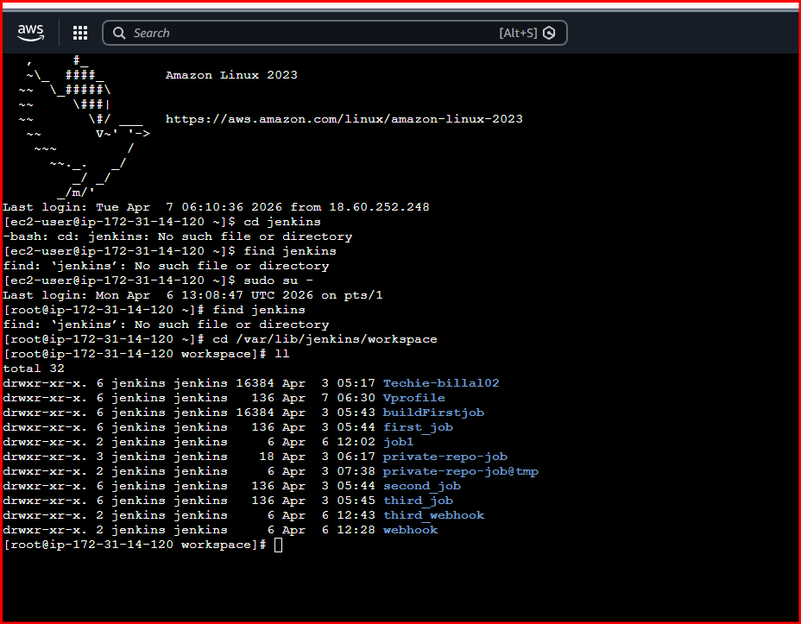
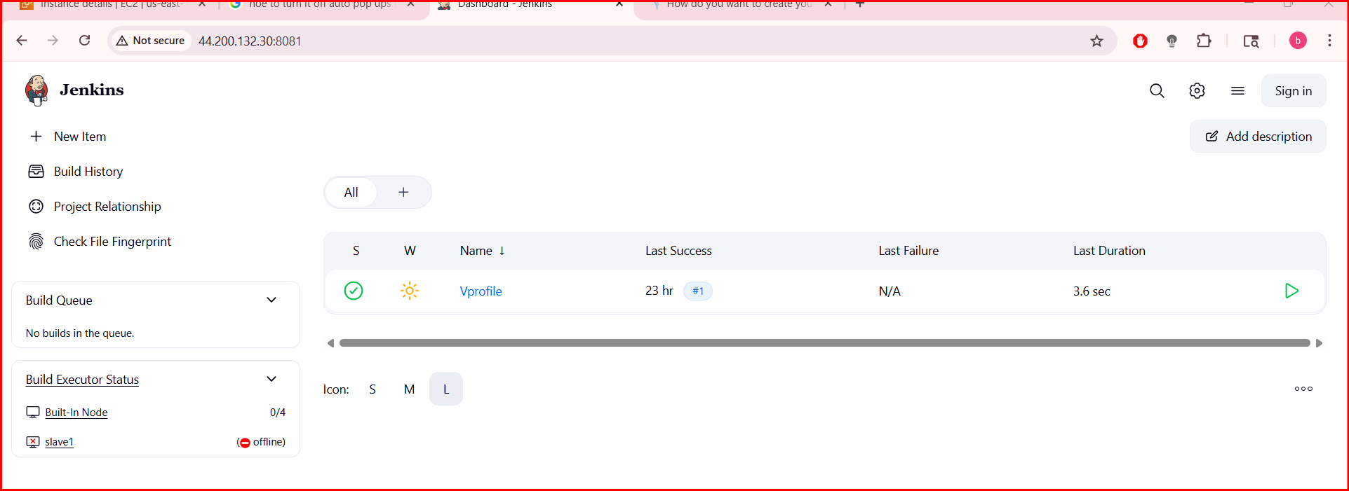
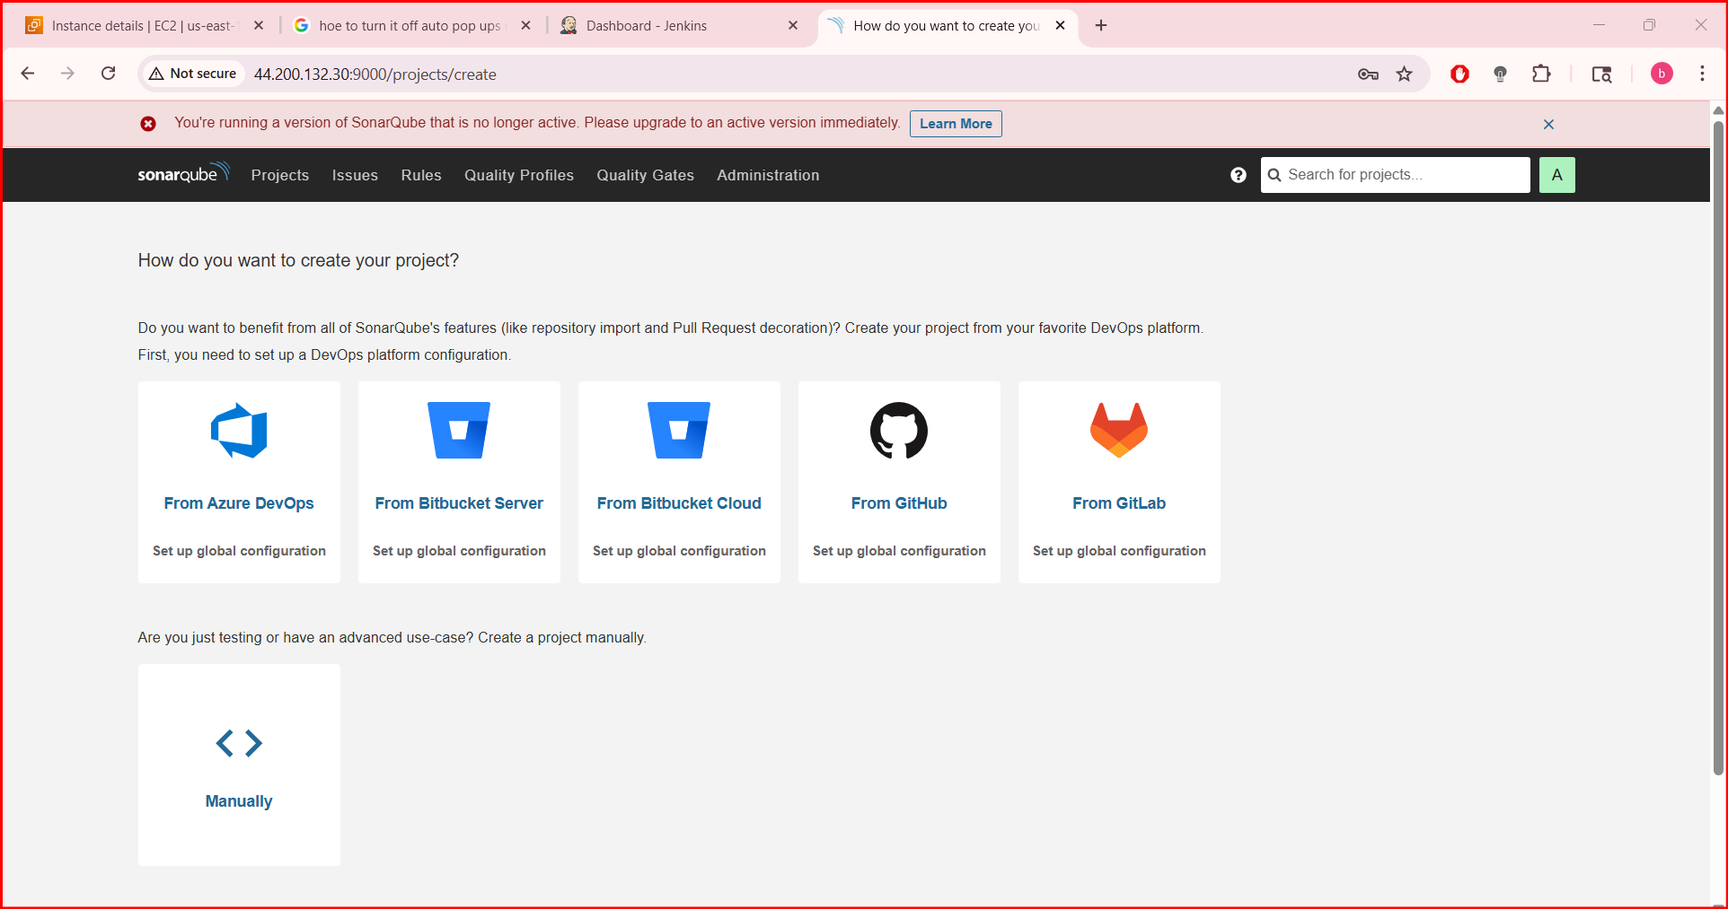

Go to:
My Account → Security
Generate token:
- Name: jenkins-token
- Click Generate
Copy token (very important)
Step 2: Add Token in Jenkins
Open Jenkins
Go to:
Manage Jenkins → Manage Credentials
Click:
- (global) → Add Credentials
Fill:
- Kind: Secret Text
- Secret: (paste SonarQube token)
- ID: sonar-token
- Description: Sonar Token
Step 4: Configure Sonar Scanner Tool
Go to:
Manage Jenkins → Global Tool Configuration
Find SonarQube Scanner
Click Add
- Name: SonarScanner
- Check Install automatically
Save
3. Configure SonarQube
Go to: Manage Jenkins → Configure System
- Find SonarQube Servers
- Add:
  - Name: SonarQube
  - URL: http://<your-sonar-server>:9000
  - Token: (generate from SonarQube)

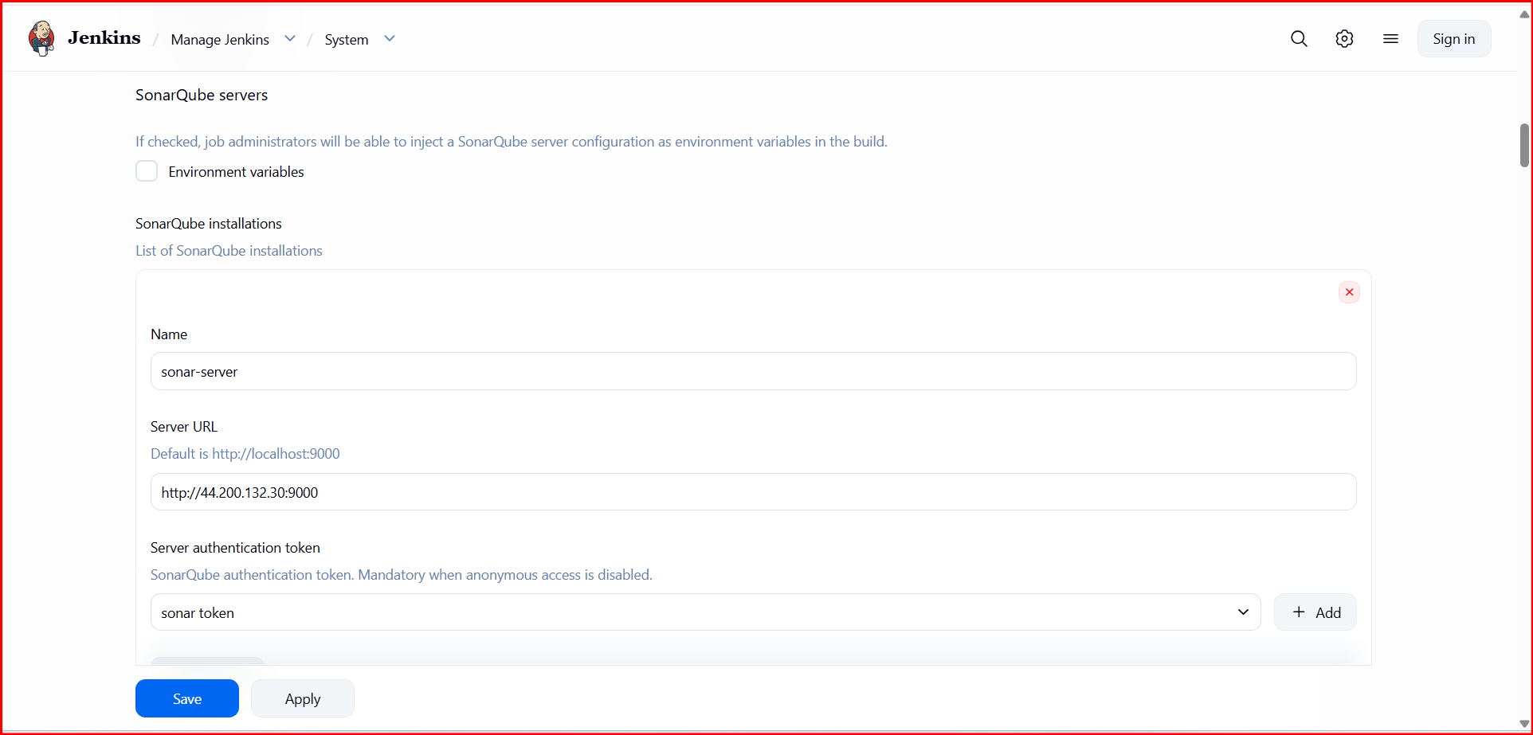
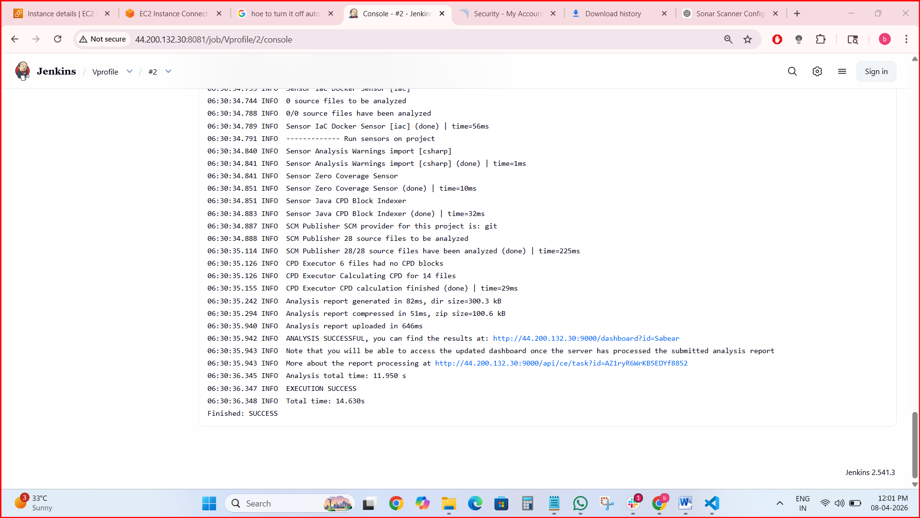
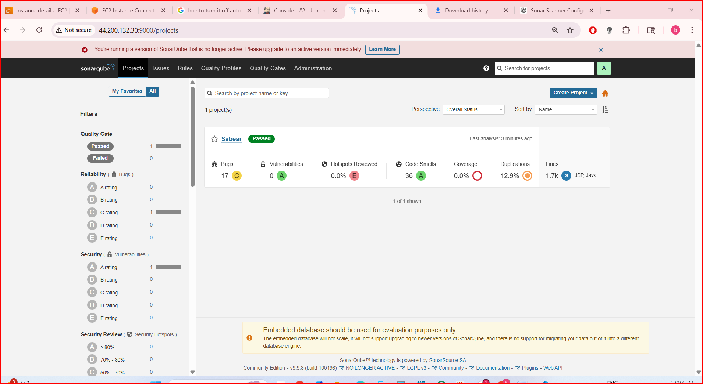
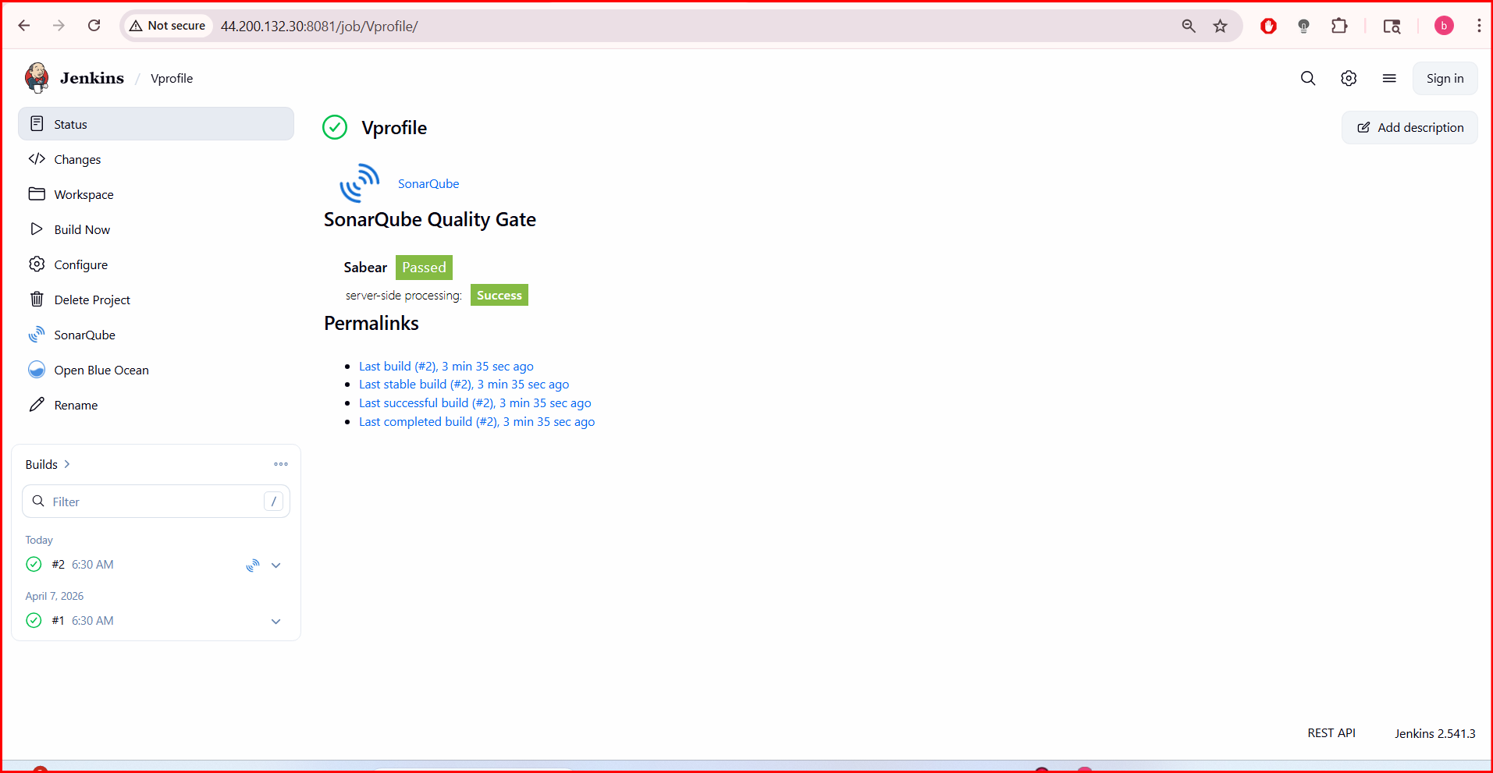
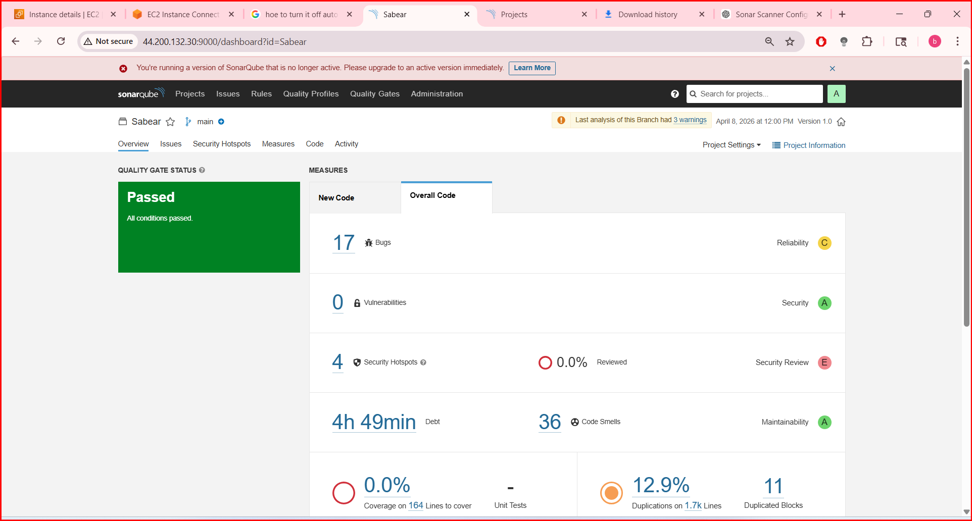
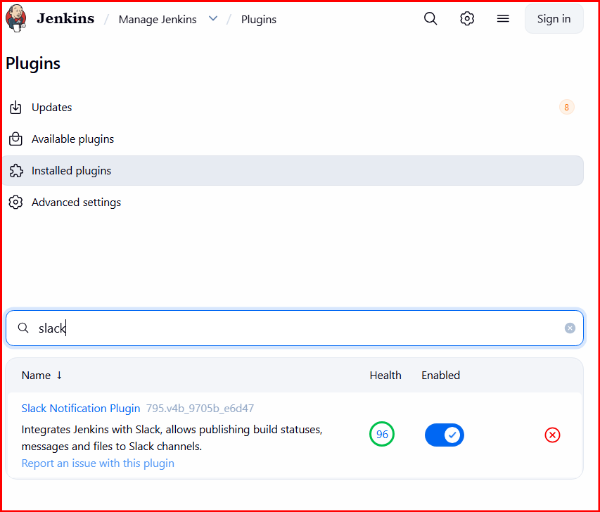
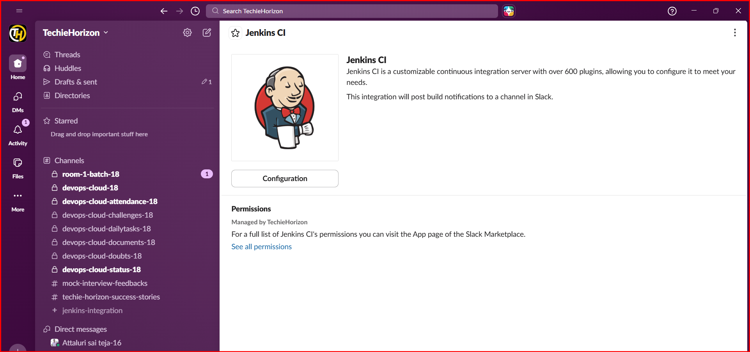
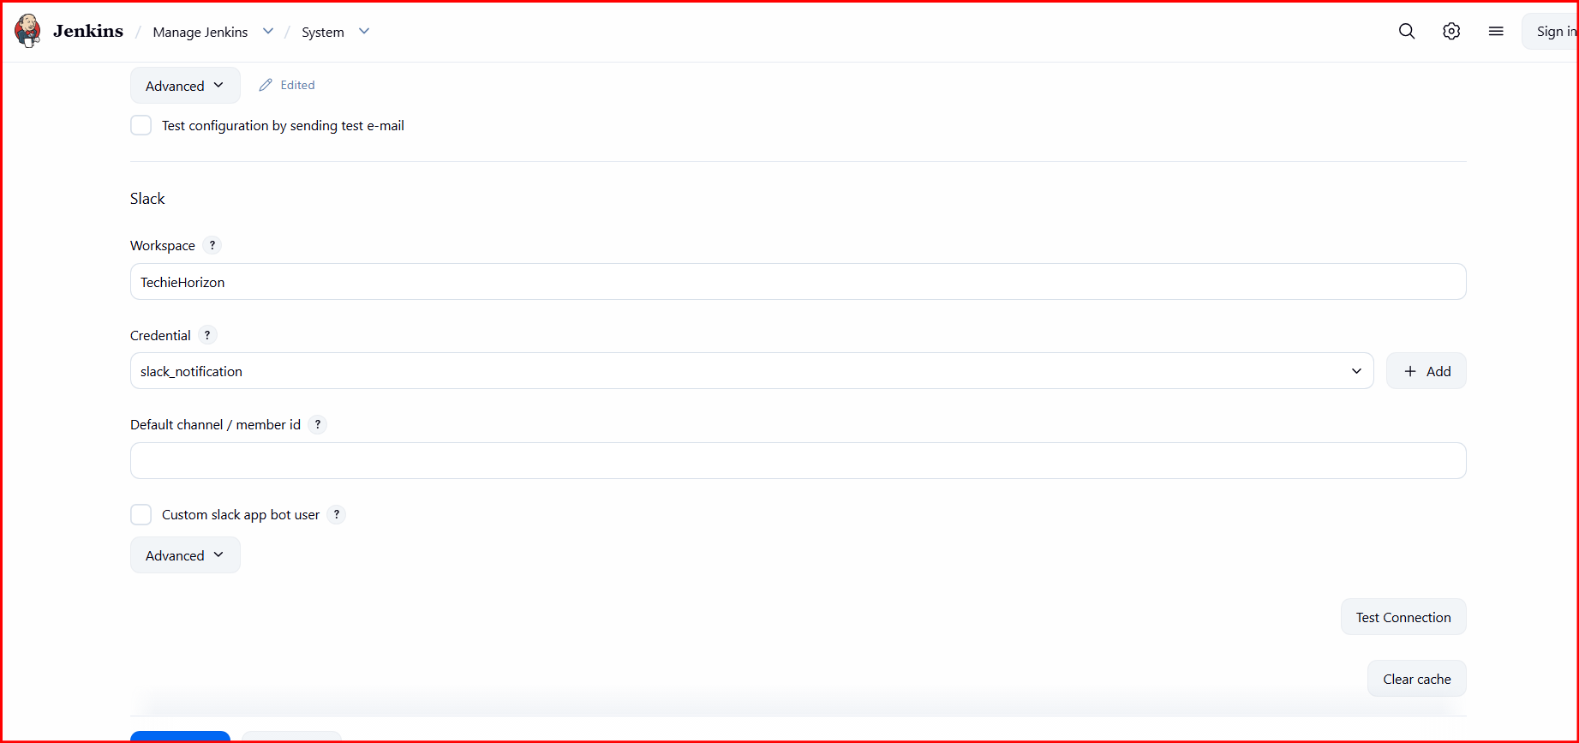
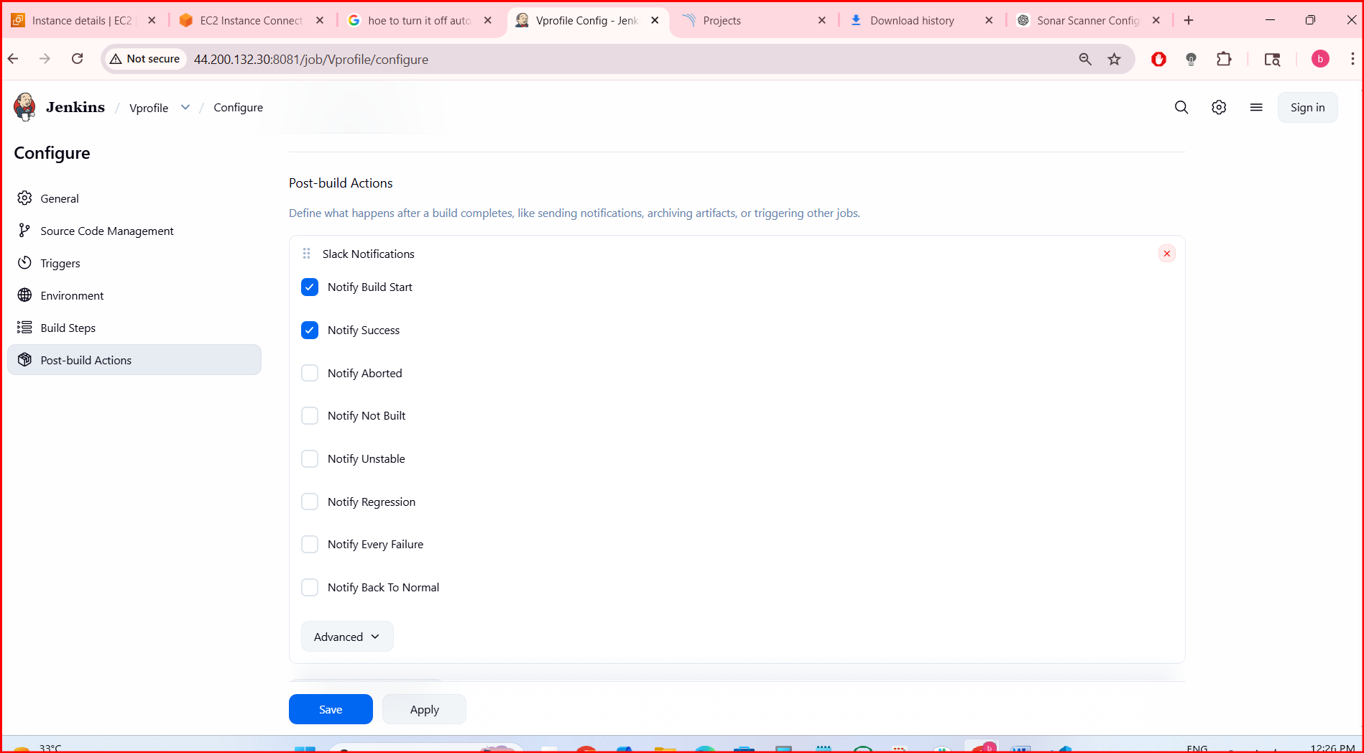
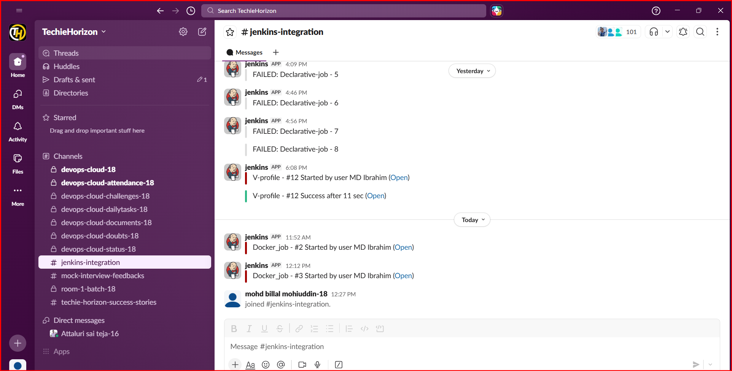
2. Create one Jenkins job using the below code and create three stages.
- stage1: Git clone to download the source code.
- stage2: Sonarqube Integration to check the quality of code.
- stage3: Slack Integration to send the alerts to slack.
Source Code: https://github.com/betawins/hiring-app.git

- Create a job in Jenkins
- Provide description and continue
- Provide the Git repo name.
- Add the details in analysis properties which available in repo
- Enable slack notifications and continue
- After saving the job was successfully created and will test
After restarting the ec2 instance we need to update some details and need to integrate with Jenkins so that generate a token in sonarqube and copy it
- Pate the token in Credentials in Jenkins and continue by clicking on save
- Also change the EXECUTE SHELL COMMANDS with new ip and new token
- After saving again click on build and continue by verifying at SONARQUBE
- Also slack was integrated in build steps so that we can verify the notification in slack also

